Python Assignment Submission

1. Grade Checker

Objective
Write a Python program that takes a student's score as input and prints the corresponding grade using if-elif-else statements.
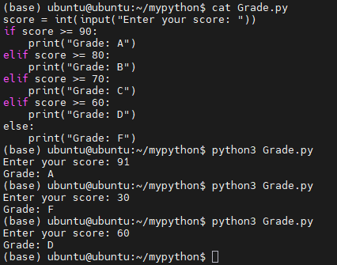
Code
score = int(input("Enter your score: "))
if score >= 90:
print("Grade: A")
elif score >= 80:
print("Grade: B")
elif score >= 70:
print("Grade: C")
elif score >= 60:
print("Grade: D")
else:
print("Grade: F")

Explanation
- The user enters a score.
- The program checks the score using if-elif-else conditions.
- Based on the score range, the corresponding grade is displayed.

2. Student Grades Dictionary

Objective
Create a dictionary to store student names and grades. Allow users to:
- Add a new student.
- Update an existing student's grade.
- Display all student grades.
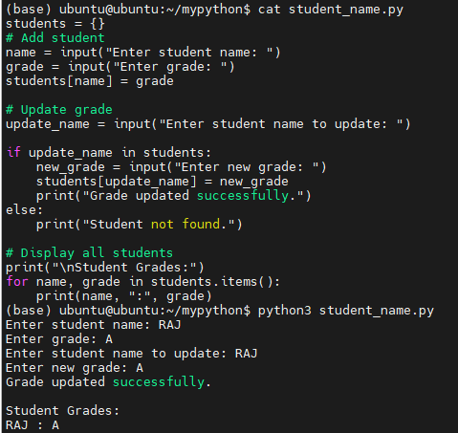
Code
students = {}

# Add student
name = input("Enter student name: ")
grade = input("Enter grade: ")
students[name] = grade

# Update grade
update_name = input("Enter student name to update: ")

if update_name in students:
new_grade = input("Enter new grade: ")
students[update_name] = new_grade
print("Grade updated successfully.")
else:
print("Student not found.")

# Display all students
print("\nStudent Grades:")
for name, grade in students.items():
print(name, ":", grade)

Explanation
- A dictionary stores student names as keys and grades as values.
- New entries are added using students[name] = grade.
- Existing grades can be updated using the student's name.
- The dictionary is displayed using a loop.

Sample Output
Enter student name: RAJ
Enter grade: A
Enter student name to update: RAJ
Enter new grade: A

Student Grades:
RAJ : A

3. Write to a File

Objective
Create a text file and write content into it.
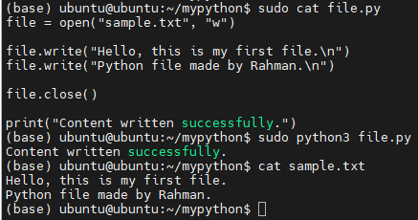
Code
file = open("sample.txt", "w")

file.write("Hello, this is my first file.\n")
file.write("Python file handling example.")

file.close()

print("Content written successfully.")

Explanation
- open("sample.txt", "w") opens the file in write mode.
- write() is used to write content to the file.
- close() saves and closes the file.
Sample Output
Content written successfully.

File Content (sample.txt)
Hello, this is my first file.
Python file handling example.

- Read from a File

Objective
Read and display the contents of a text file.
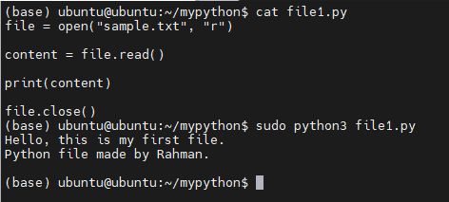

Code
file = open("sample.txt", "r")

content = file.read()

print(contenit)

file.close()

Explanation
- The file is opened in read mode ("r").
- read() reads all content from the file.
- The content is printed on the screen.
Sample Output
Hello, this is my first file.
Python file handling example.

